

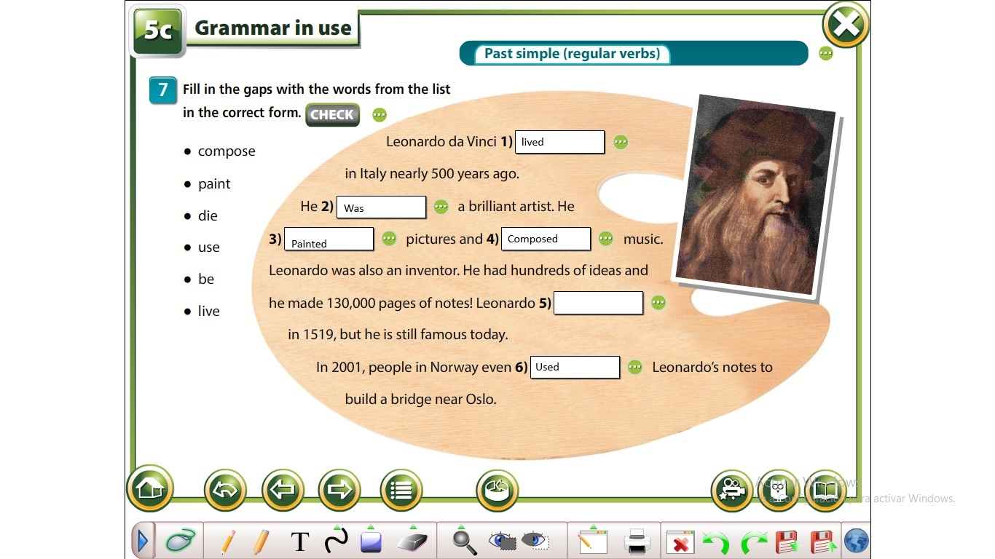

My yesterday's routine

I got up at 4:30 a.m. to get ready for work.

I took the Transmilenio at 5:20 to get to work.

Work started with the planning of tasks at 7:30 a.m.

I was in several meetings throughout the day

Fixed bugs in an application

Had lunch at 1:00 p.m.

Had an integration activity at 3:00 p.m.

When I left, I went to train until 7:00 p.m.

Then I went to visit a friend I hadn't seen in a long time

Finally we had pizza for dinner and talked a lot